**Output of 1(A) :-**

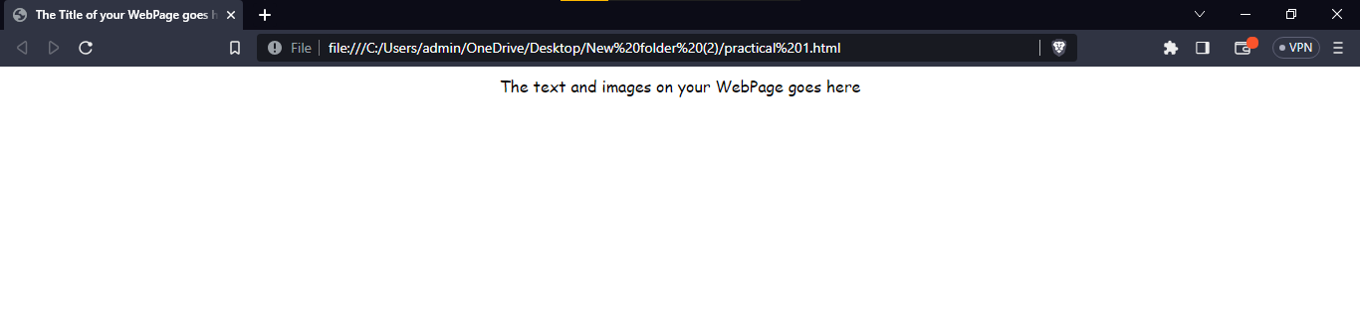

**Output of 1(B) :-**

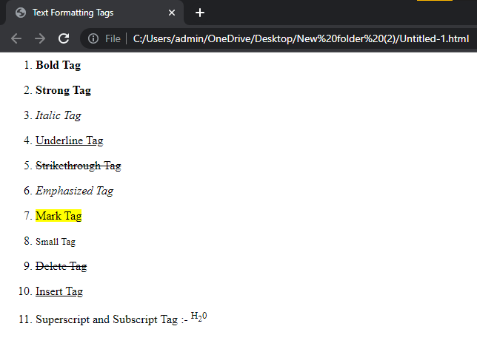

**Output of 1(C) :-**

1. **Unordered List :-**

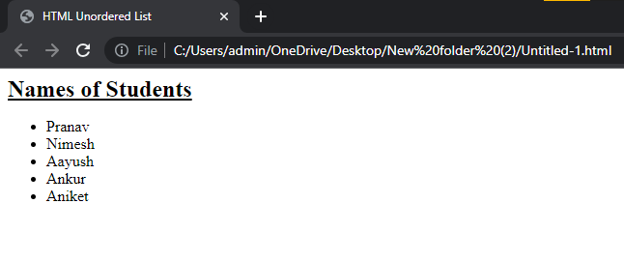

1. **Ordered List :-**

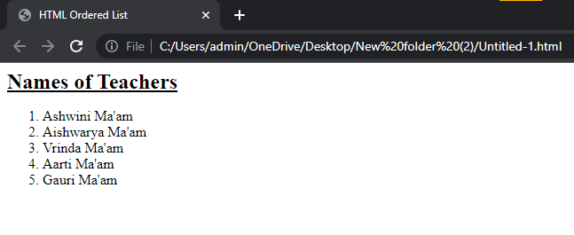

**Output of 1(D) :-**

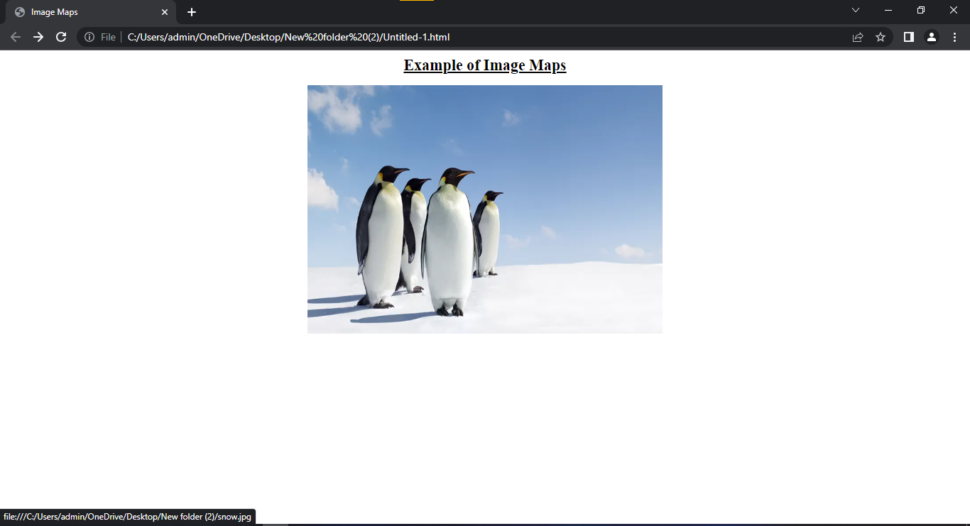

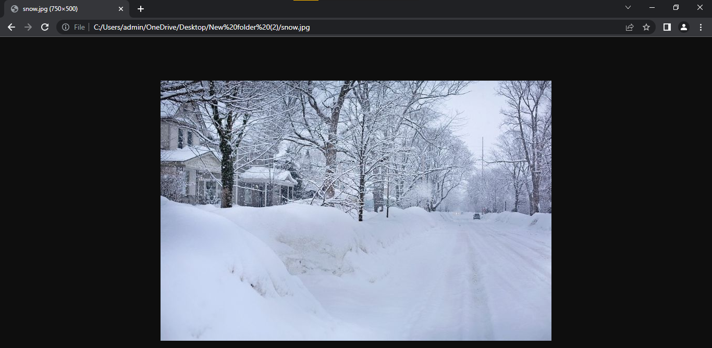

**Output of 2(A) :-**

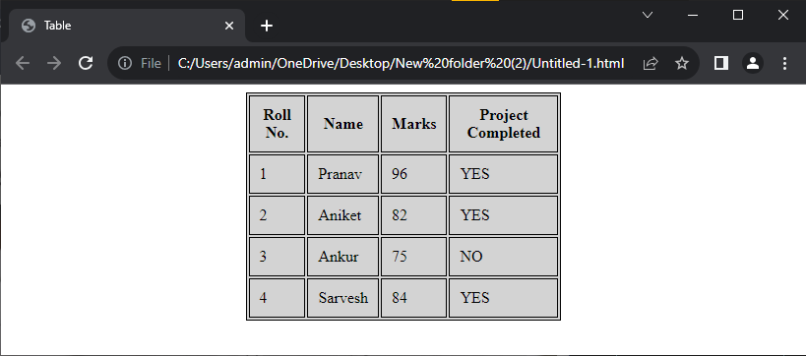

**Output of 2(B) :-**

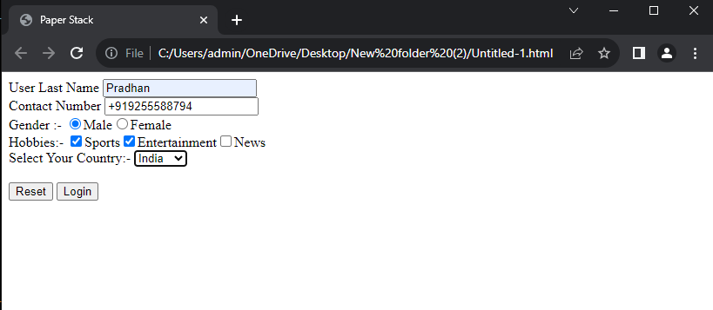

**Output of 2(C) :-**

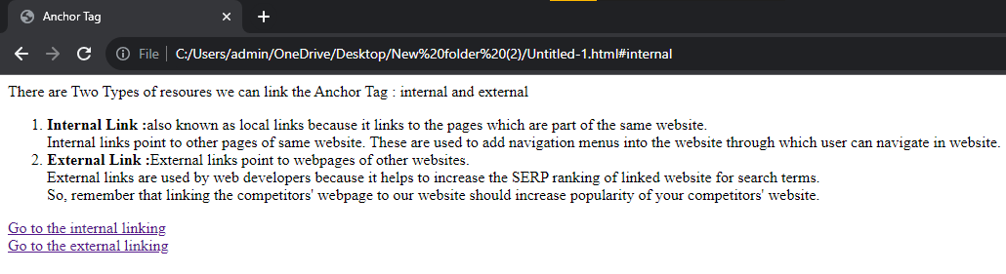

**Output of 2(D) :-**

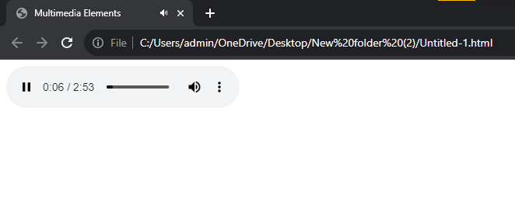

**Output of 3 (A) :-**

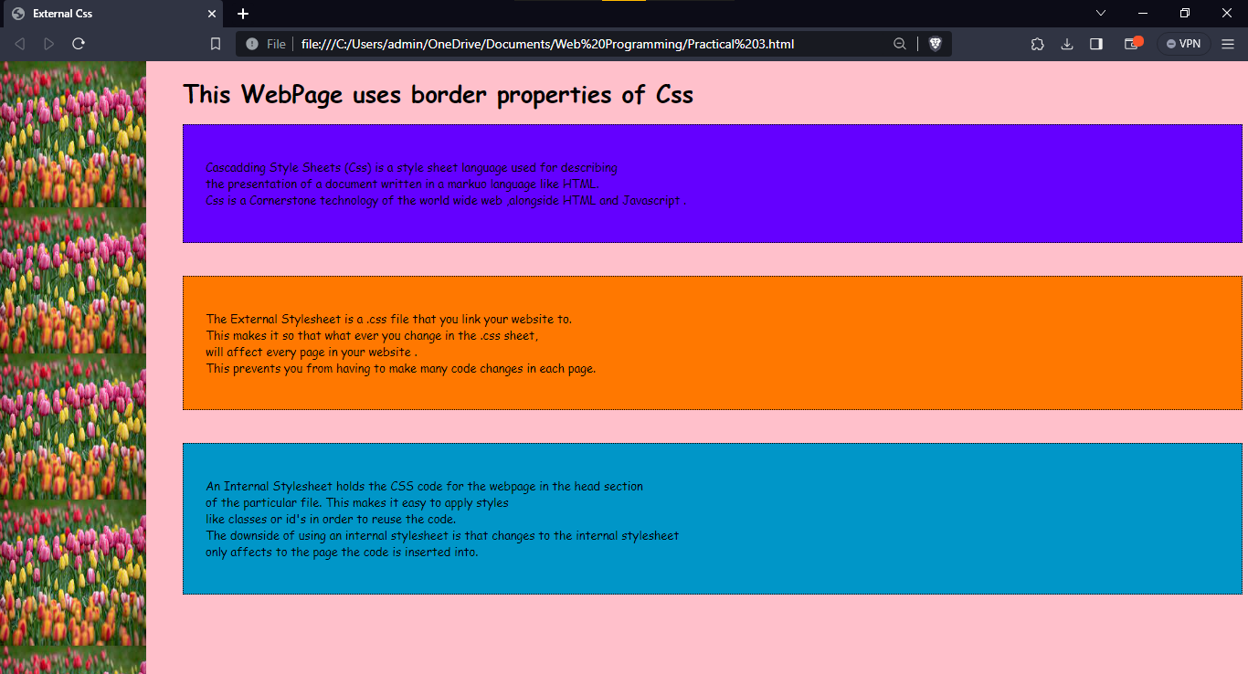

**Output of 3 (B) :-**

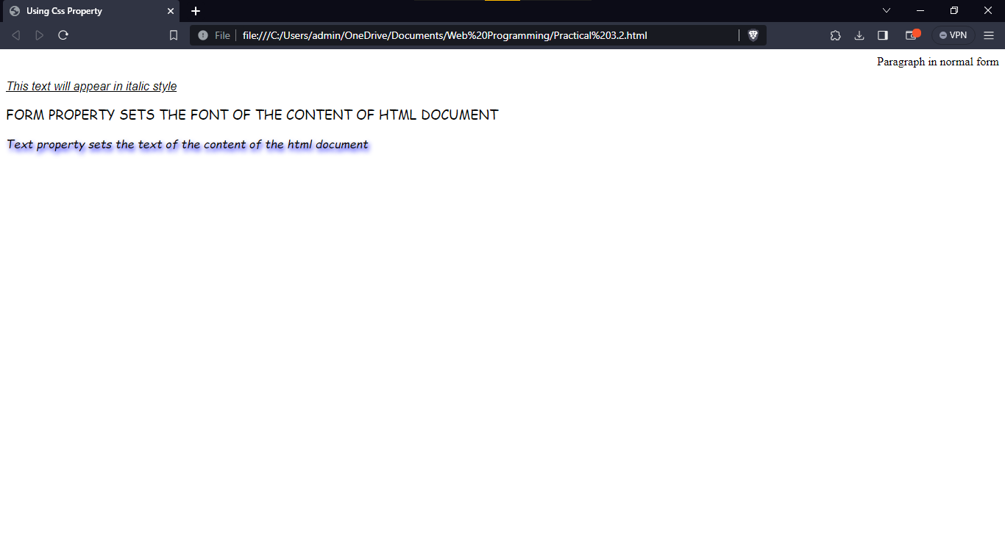

**Output of 3 (C) :-**

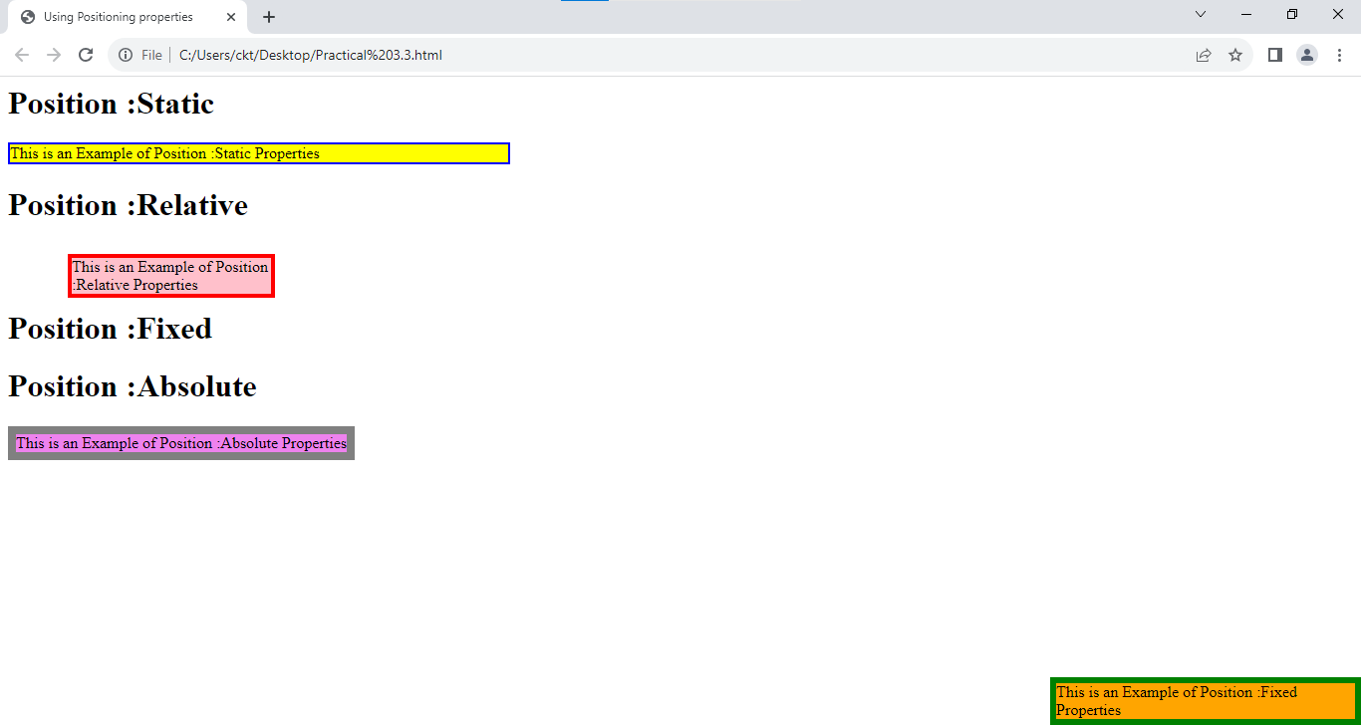

**Output of 5 (A) :-**



**Output of 5 (B) :-**



**Output of 5 (C) :-**



**Output of 5 (D) :-**



**Output of 5 (E) :-**

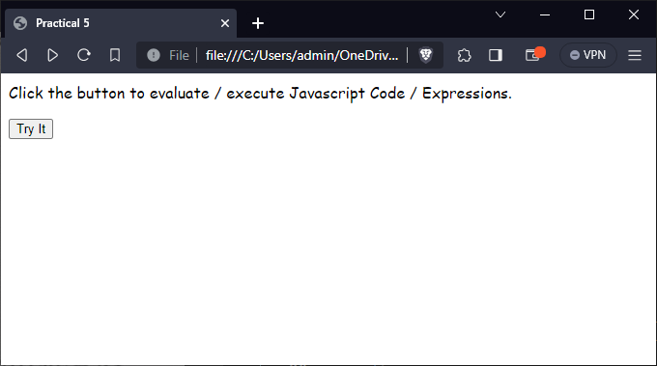

**Onclick :-**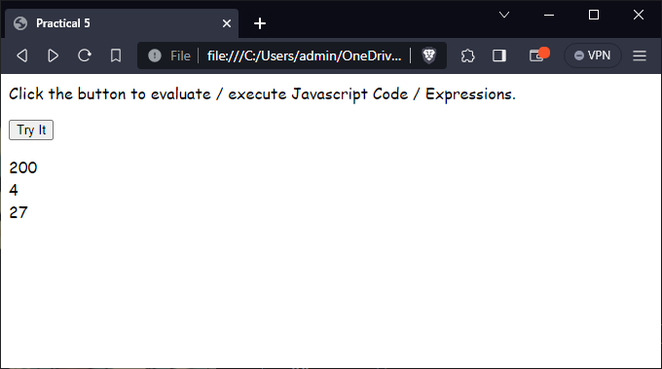

**Output of 5 (F) :-**

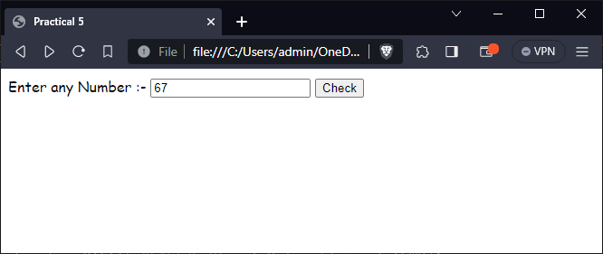

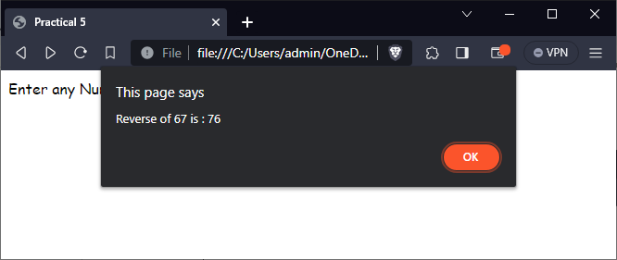

**Output of 6 (A) :-**



**Output of 6 (B) :-**



**Output of 6 (C) :-**



**Output of 6 (D) :-**



**Output of 6 (E) :-**



**Output of 7 (A) :-**

1. **Regular Expression :**



1. **String :**

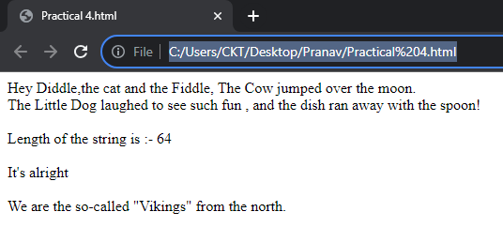

1. **Math :**

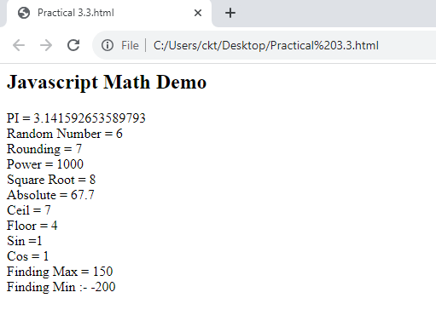

1. **Date :**

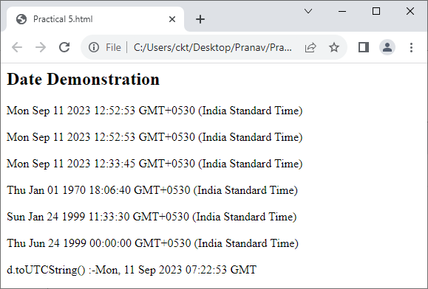

**Output of 7 (B) :-**

1. **Window Object :** 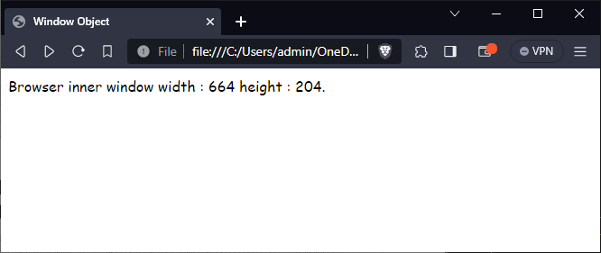
2. **Navigator Object :**

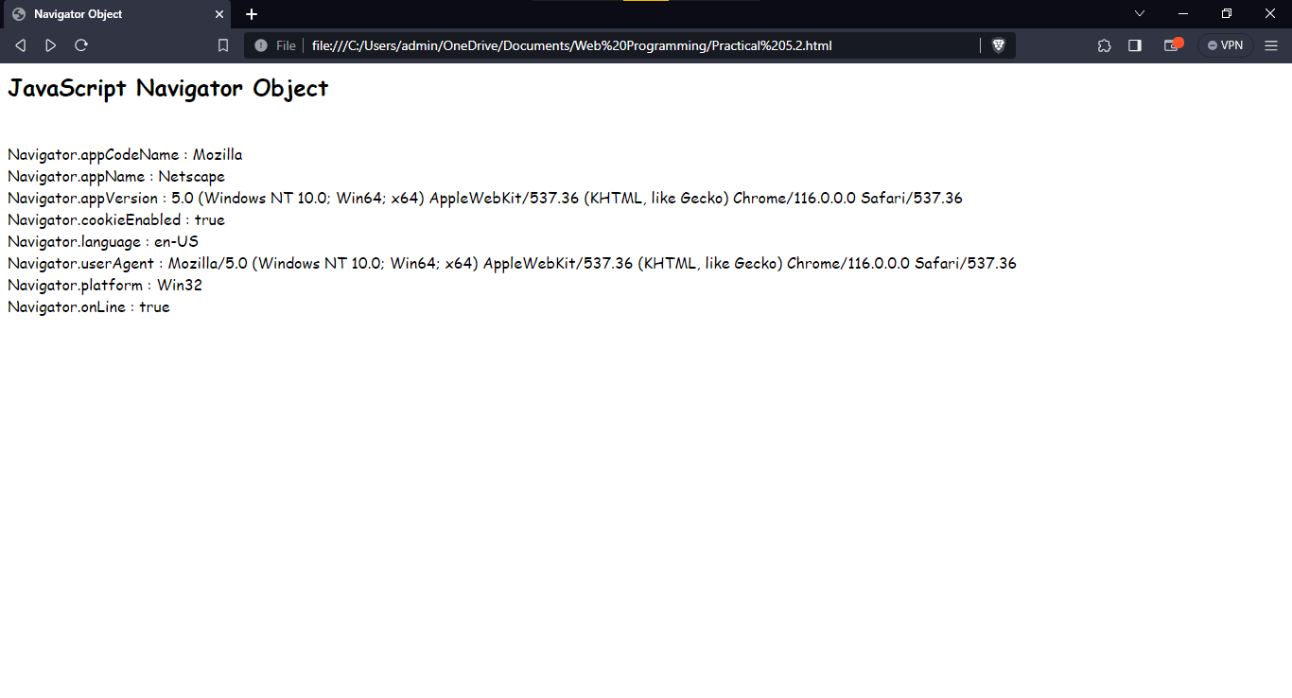

1. **History Object :**

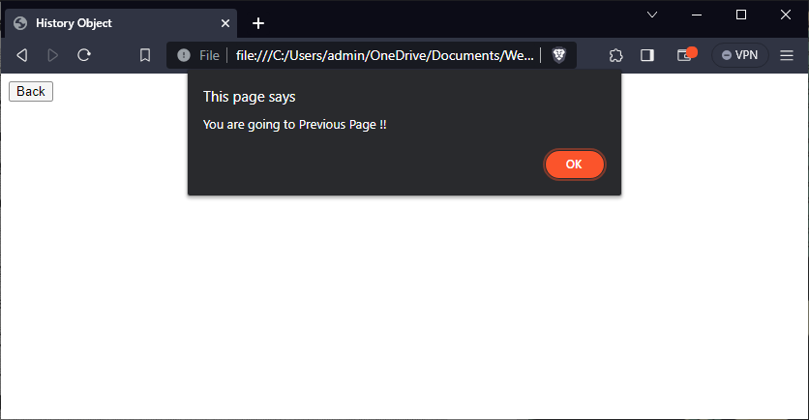

**OnClick :** 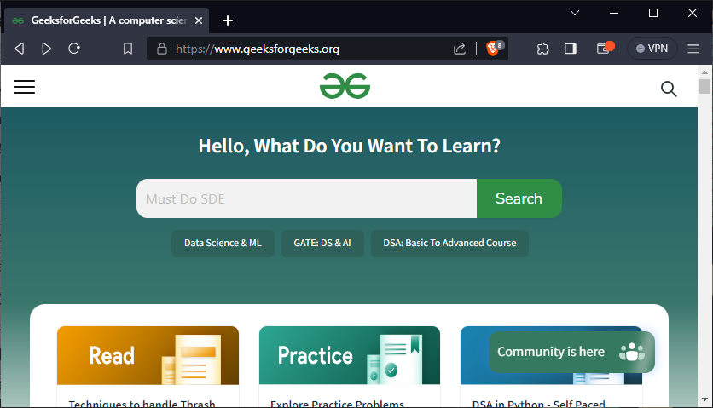

1. **Location Object :**

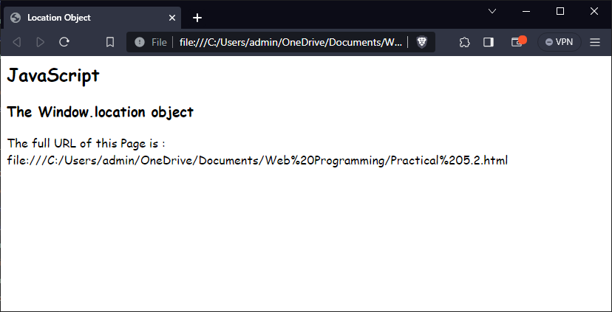

1. **Document Object :** 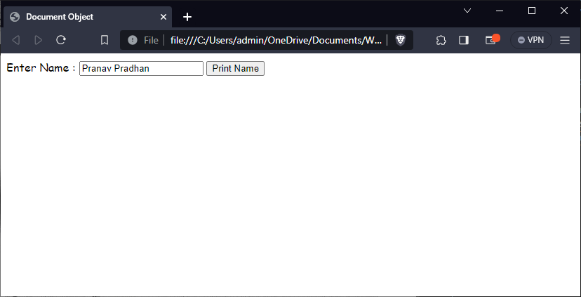

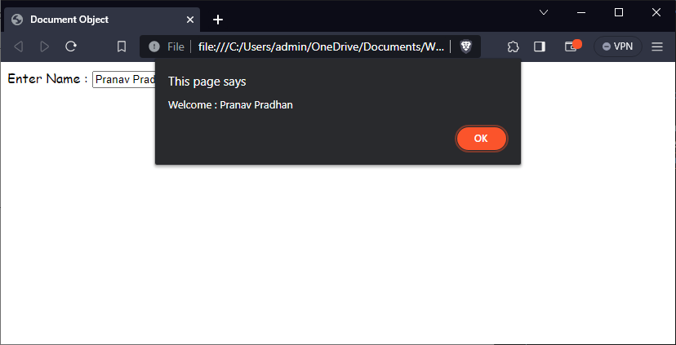

**Output of 8 A :-**

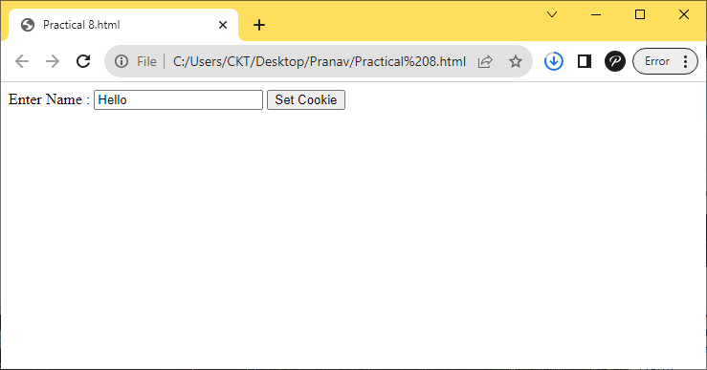

**Onclick : -**

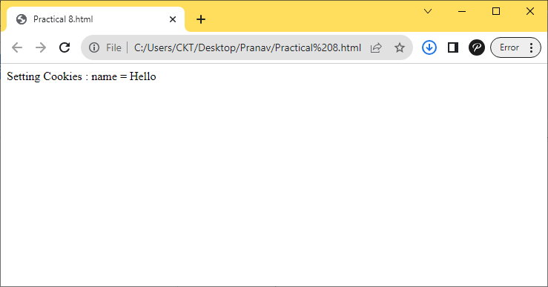

**Output of 8 B :-**

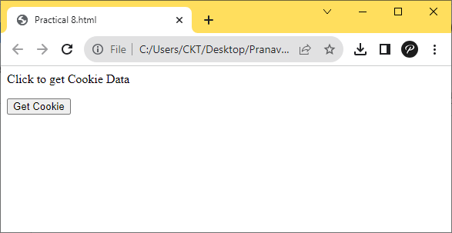

**Onclick :-**

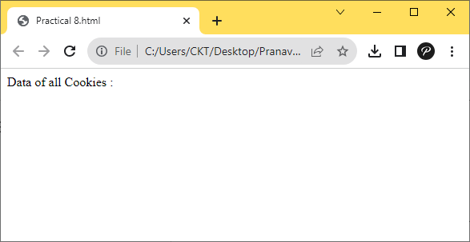

**Output of 9 A :-**

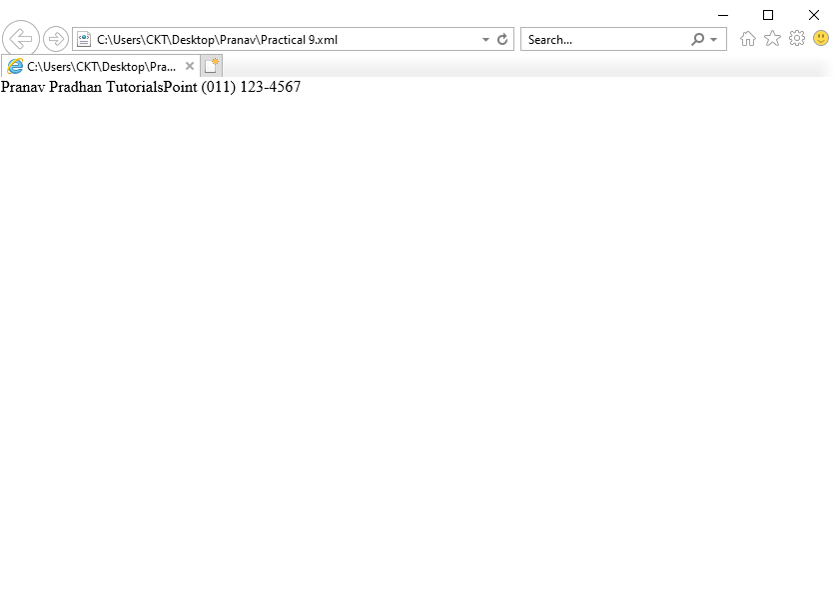

**Output of 9 B :-**